
EUROPEAN RACING
ORGANISATION
OFFICIAL RULES

The rules below apply to European Racing Organisation racing league and community.

RECRUITMENT

Before every season starts, there is a recruitment organised. It has the purpose to sort out drivers to divisions being proper for their race pace and experience.

Joining recruitment:
- Driver has to fill a form suitable for his platform, which is available in #join-racing
- Driver has to answer questions correctly in the form - everything is explained inside it
- A proper Time Trial photo has to contain the whole screen and has to be easily readable.
  - Example: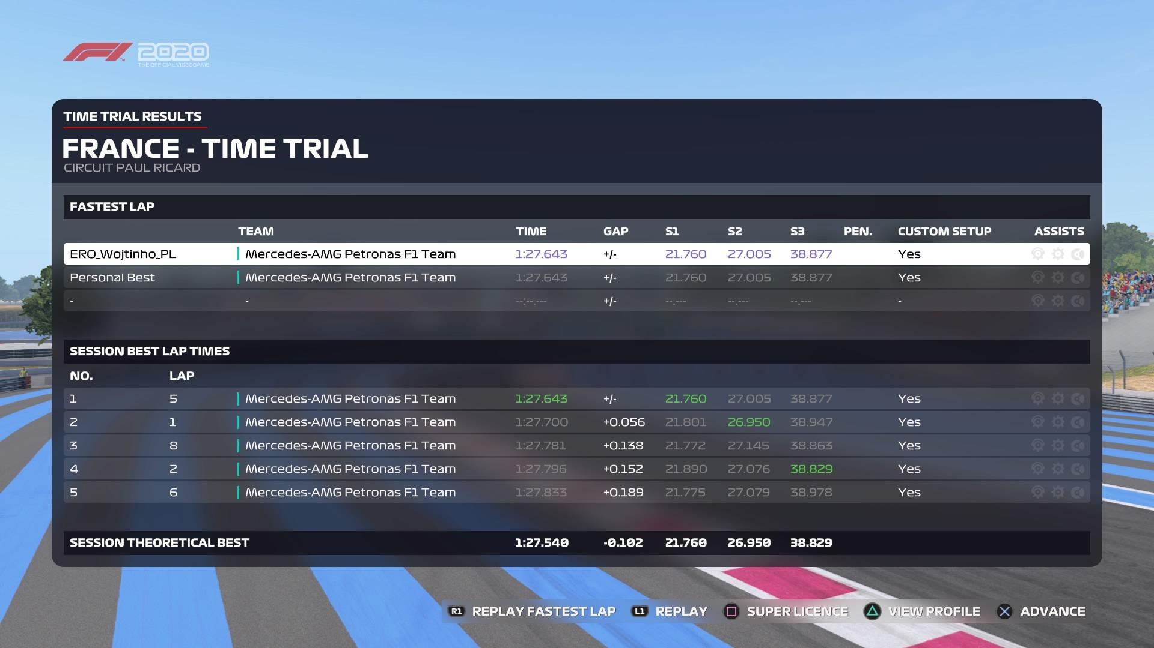

There are 4 factors deciding in which division a driver will be in:
- Time Trial being held on 3 tracks - one technical, one quick and one street.
  - One track has to be wet - it is selected randomly
- Experience Points - includes:
  - Points being given due to starting in previous ERO Seasons
  - Points being given due to achievements in last two ERO Seasons - includes high positions in the championship, Driver Of The Week points, and race wins
  - Points being given due to performances in other leagues
  - Points being given due to performances in Featured Leagues - these are a few selected leagues which are known to be major and where many quick drivers race in.
- Trial Race on a track which is not in calendar for next season
- Assists used by a driver

Rules of each factor:
- Time Trials: the slowest driver on one of the tracks gets 1 point to recruitment. The second slowest driver gets 2 points, then 3, 4, and it continues until the fastest driver gets points. A driver gets 1 more point in comparison to one behind him.
- Experience Points:
  - Amount of them is decided at the beginning of next season’s recruitment
  - Driver gets 3 points for every season he started in ERO [if he started in more than 5 races in each]
  - Driver gets 1 point for every single win in last two seasons, no matter what was a division where he won
  - Driver gets 1 point for every single Driver Of The Week point from last season
    - From Season 5, being part of DOTW voting equals with 1 point. Second place gets 2 points and a winner gets 3.
  - The higher the division driver was in and in which driver has got a better position, the more points he gets.
  - From other leagues, a driver can get points from taking part in one, finishing a full season with 50% of attendance, finishing in TOP 5 or winning it
  - From featured leagues, there is a separate system of awarding with XP Points. Points may be given by taking part in last year in that league and for achievements there. Amount of maximum points being given from each league is decided by ERO’s owner
  - ERO PS4 F1 Champion from last season cannot get more than 75 points from winning it
- Trial Race: is held on one of the tracks which is not on the calendar. It is a normal 50% race, but with no collisions, no Safety Car, clear weather and reduced damage. Race pace is the only factor depending. A driver with slowest race pace gets 1 point, second slowest gets 2 and more.
  - Lapped drivers are considered into a separate standings. They will not compete with drivers who completed the whole race distance. Example: if there are 10 drivers who were lapped in all lobbies, those 10 are considered to get points from 1 to 10. What matters is position in the standings and how many laps a driver lost to a winner. The slowest driver out of all lobbies not to be lapped gets 11 points automatically.
  - Drivers from each day get points according to standings of that day. Saturday drivers get points in their own standings, same as Sunday drivers get.

Standings rules:
- The 20 Drivers who got the most points are going to the top division. Next 20 go to a second one, and it continues until last division possible to create
- 5 last drivers to qualify to a tier may go by 1 lower division if they request to do so
- Drivers may go to a reserve of higher tier if they request to do so and when they:
  - are not able to race on the time of lower tier
  - and/or are quick enough for a higher division. Only Time Trials matter in that case
- If two or more drivers have exactly the same time on one of the tracks, the one who filled a form earliest is considered to get more points
- If two or more drivers have an exact amount of points in recruitment, the one who got most points from one of the tracks will be placed ahead. If every of them have the same best score from time trials, Trial Race points decide

LOBBY

To start a session, there is a lobby needed. It is a task of a host to create it, set it up and invite people racing in a division.

Lobby settings:
- Session options
  - AI Driver Level: 41 (Medium)
  - Category: F1 2020
  - Car Performance: Equal
  - Maximum players: 22
  - Practice Length: None
  - Qualifying: Short (18 min)
  - Race Distance: 50%
  - Quick Weather: Dynamic
  - Session Start Time: Official (Exception: Monaco - midnight)
  - Session Privacy: Invite Only
- Race settings
  - Parc Fermé Rules: On
  - Collisions: On
  - Car Setup: Full
  - Safety Car: On
  - Rules and flags: On
  - Corner Cutting Stringency: Strict
  - Formation Lap: On
  - Race Starts: Manual
  - Tyre Temperature: Surface & Carcass
- Assist Restrictions
  - Depends on a division
  - In every single tier, following assists are turned off:
    - Braking Assist
    - Pit Assist
    - Pit Release Assist
    - ERS Assist
    - DRS Assist
    - Fuel Assist

Lobby preparation
- From side of hosts
  - A lobby is supposed to be created in 20 to 15 minutes before a qualifying session to start by a host
  - Once it’s set up, drivers have to be invited at least 10 minutes before the qualifying session to start
  - Host may be a driver or second commentator. Usually the second one is intended to be division’s coordinator
- From side of drivers
  - Driver has to join session at least 5 minutes before qualifying session to start and pick a team as soon as he joins
    - if a driver reports being late at least 2 hours before a race, he is able to join during qualifying
  - Driver cannot click the Ready Up button before the division's coordinator gives a signal to do so.
  - To make a session going, there have to be 10 drivers at least. Otherwise - race still may happen, but it will not be counted to championship standings and will have no stream
  - Drivers have to keep in mind they have to pick a flag of their actual nationality - there is no random country pick allowed.
    - Flag rules:
      - A driver may pick a flag in terms of:
        - country of current living
        - country of birth
        - country in which they have citizenship
        - country of close family (this considers: mother, father, grandfathers, grandmothers, wife, husband)
      - putting wrong country’s flag equals with a community warning (a driver has to prove there was a bug for removing this)
        - there may be a flag named “Other” or “Rest of World” if there is none of driver’s one.
- From side of commentators:
  - Both commentators have to join the lobby as soon as they are invited and click the Spectate button. Thanks to that, they will be able to set up stream without any problems
  - Commentator has to start broadcast as soon as 10 drivers are in lobby
  - They have to set up a stream in quality of at least 720p. 60 frames per second are not required, but a streamer has to put quality of video as good as it causes no problems to delay or to his connection.

Lobby delays:
  - Lobby is intended to start at planned session’s start time, however, there may be a delay because of:
    - sudden technical issues of at least one driver or lobby - up to 5 minutes
    - a request of at least one driver - up to 10 minutes, has to be requested at least 2 hours before a race

Lobby restarts:
  - Lobby may be restarted before reaching 50% of distance due to following circumstances:
    - drivers being stuck in grid, not able to start race or formation lap
    - massive disconnection of at least 4 drivers in space of 3 laps [cannot be intentional]
    - driver being put in last place regardless of his real qualifying position [only on driver’s request]
    - drivers heavily lagging
    - driver(s) causing intentional collision in first laps of a race - equals with immediate disqualification from a race for that driver(s) and them not being invited to a new lobby
  - Lobby will not be restarted due to:
    - massive unintentional collision
    - one driver disconnecting
    - problems after reaching 50% of distance - if leader did not reach 75% of laps, half of points are given
    - a driver being put in wrong team - if a full-time driver is in wrong team, he will be considered as driver of his actual team anyway and get points for them [when it is a major issue and more than 4 drivers are in wrong teams, lobby is restarted]
  - Restart procedures:
    - When restarting, host or coordinator is supposed to ping entire division on Discord announcing Lobby restart
    - Once doing it, host has to create and set a new lobby and invite drivers as soon as possible
    - Grid settings:
      - If a restart happened at beginning of qualifying (more than 12 minutes to go), qualifying is set as short again
      - If a restart happened midway qualifying (12 to 3 minutes to go), one-shot qualifying will be held
      - If a restart happened at the end of qualifying (less than 3 minutes to go), standings of qualifying at last time of driver putting a lap without glitch is considered to be qualifying standings - a driver on provisional pole gets Pole Position point
      - If a glitch (which is the reason for restarting the lobby) happened before the race even started - qualifying standings are valid and they create starting grid
      - If a glitch happened after race start but before 50% of the race completed - the order will be taken at the last point at which it was possible to determine the position of all cars & the whole race distance (without formation lap) will be done again. All such cars will then be permitted to resume the race.
      - Race can be restarted if there is time to complete the race before 2 hours have passed from the scheduled start time.
    - Restart cannot be done later than 15 minutes starting from the lobby's glitch.
    - There can be only one restart of lobby
    - If there is a lobby glitch once again even after restarting, race is supposed to be cancelled or postponed.
      - When postponed, the red-flagged race is going to longer a season by a week - as it’s moved to be one week later than the last race in the calendar. Terms of other races are not changing.
      - There can be only two postpones in a season - if there are more problems, races will be cancelled and no postpone happens

ABSENCES

If a driver cannot race, he has to report it so there is no mess about attendance in lobby
- A driver is supposed to report an absence or being late at least 2 hours before the qualifying session starts.
  - It has to include a valid reason, which is more explanational than “I can’t race today”
- Not taking part in a race with not reporting an absence equals with unreported absence
  - 2 unreported absences in a row or 3 in general equal with a season ban
- A driver has to announce that he can actually race at least 45 minutes before a session to start

LEAGUE TAGS

A broadcast is supposed to look tidy, and leaderboard is supposed to provide readable ingo. That is why ERO league tags are created.

- Using the ERO name tag is heavily recommended in ERO league races
- The template of the name tag is:
      - ERO_
      - Your shortened nickname - Remove all of the numbers, Random letters or another codes_
      - Shortcut of your nationality
- Examples: ERO_Wojtinho_PL, ERO_Vilzu_FIN, ERO_Libenow_SK

PENALTY POINTS

Penalty points are given for a driver who has been in fault in an incident
- A steward can apply from 1 to 5 Penalty Points to Driver's licence if he receives a penalty
- If a driver collects 6 Penalty Points, it equals with Qualifying ban, and if a driver collects 10 Penalty Points, it equals with a race ban. For 12 and 18 Penalty Points a driver will get another qualifying ban.
- Getting 2 Race Bans equals with disqualification from the rest of season
​

COMMUNITY WARNINGS

ERO cannot be a toxic community - that is a reason for creating a community warnings system in the league.
- Community warnings are given to the drivers who are constantly making at least one of the things listed:
  - Spamming
  - Causing a massive argument
  - Flooding
  - Complaining about admins or league anywhere without actual reason, including offending, bad words and more (however, substantive criticism is allowed)
  - Offending other drivers, including curse words
- Getting 3 Community Warnings in one season lead to permanent ban from the league
- Getting at least 8 hours temp-mute on Discord equals with automatic Community Warning (exception: temp-mute is given at night between 10 PM to 6 AM UK time)
- Community Warnings restart after a season.

LEAVING LEAGUE

- If a driver leaves a league, he has no more chance to join back during the same season.
  - Exceptions of the rule:
    - Technical issue with the console/PC
    - Major Injury or sickness
    - Important family problems
- If a driver rage quits from the Discord server, using offending words towards someone or simply just clicks “Leave server” on Discord, it equals with no possibility to come back.

POINTS SYSTEM
- Position 1: 25 points
- Position 2: 18 points
- Position 3: 15 points
- Position 4: 12 points
- Position 5: 10 points
- Position 6: 8 points
- Position 7: 6 points
- Position 8: 4 points
- Position 9: 2 points
- Position 10: 1 point
- Fastest Lap: 1 Point (driver needs to finish the race)
- Pole Position: 1 Point (driver needs to finish the race)

